
Lab Test Kit Introduction and Basic Logic Functions
Lab 1

David tapia caicedo

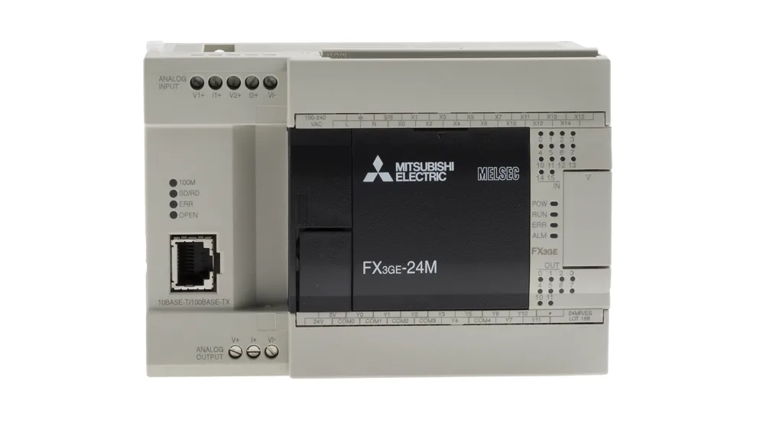
Content
Section 1 – Mitsubishi Test Kit Analysis 2
1. Mitsubishi FX3G PLC Sketch 2
2. Define the difference between contacts 2
3. Troubleshooting potential electrical fault 2
Section 2 – Truth Table Analysis 3
1. Construct a ladder diagram for each of the circuits shown below. Create a new diagram for each circuit. 3
2. Test the ladder logic to ensure there are no errors or warnings. 3
Circuit a: 3
Circuit b: 4
Circuit c: 5
Circuit d: 5
Circuit e: 6
Circuit f: 7
3. Using truth tables, establish the logic function for each circuit. Use Excel to generate a table for all variables. 7
Section 3 8
1. Diagram 8
2. PLC test unit 8
3. Wire the 3VDC motor using a control relay so that the motor operates with the ladder logic design. Hint: Two different voltages can be used to achieve the required result. 8
4. Three-phase (415V) supply Diagram 9
5. Conclusion and Discussion of results 9

Section 1 – Mitsubishi Test Kit Analysis

Mitsubishi FX3G PLC Sketch
Sketch the complete Mitsubishi FX3G PLC training kit on a full A4 sheet. Include the physical PLC, 24 V DC power supply, toggle switches, input and output devices, HMI, terminal blocks and all associated wiring. Clearly identify the PLC inputs (X), outputs (Y), power supply connections, 0 V/common connections and HMI communication connection. Produce a complete wiring schematic showing how all components of the training kit are interconnected.

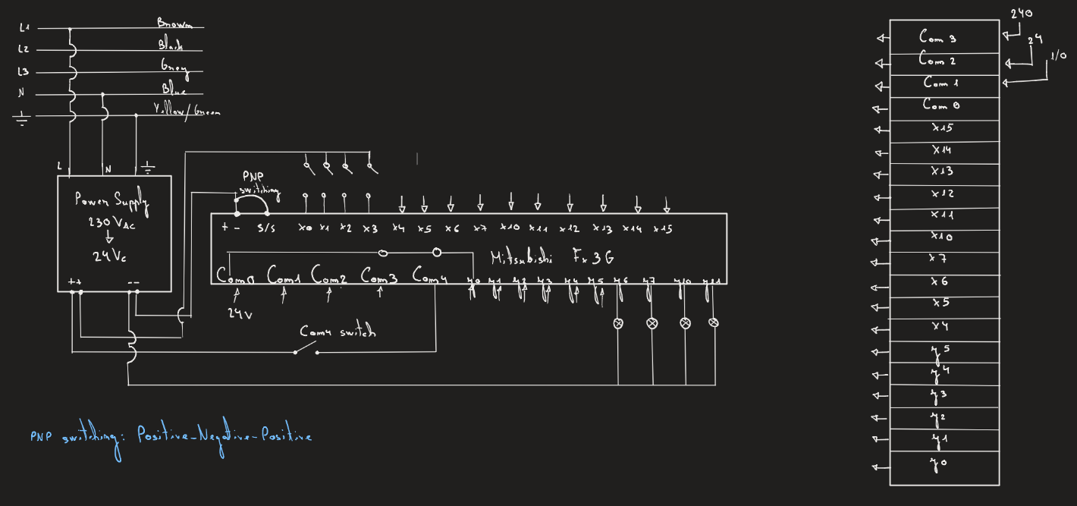

Define the difference between contacts
Define the difference between a normally open and normally closed contact and give a brief example where each could be used to perform a logical operation.
A normally open contact is one that, in its resting state, does not allow current to pass to the circuit. It only allows current to flow when activated. A practical example is a Start button on a machine's control panel.
A normally closed contact is exactly the opposite. In its resting state, it allows current to flow, whereas upon activation, it stops current from passing to the rest of the circuit. An example is an emergency stop button.

Troubleshooting potential electrical fault
State clearly when troubleshooting potential electrical fault on the test rig using your digital multi-meter, state the very first step that should take place on the test equipment and why.
When tracking down an electrical issue on the test rig with a digital multimeter, the very first thing you need to check is the power supply. You need to check that it is getting the 230V AC from the mains and providing properly the required DC voltages for the system.
If it fails or is turned off, the entire PLC loses power. Doing this step first is key to ruling out a basic power drop before moving on to trickier diagnostics with the wiring or the ladder logic.

Section 2 – Truth Table Analysis

Construct a ladder diagram for each of the circuits shown below. Create a new diagram for each circuit.

Test the ladder logic to ensure there are no errors or warnings.

Circuit a:
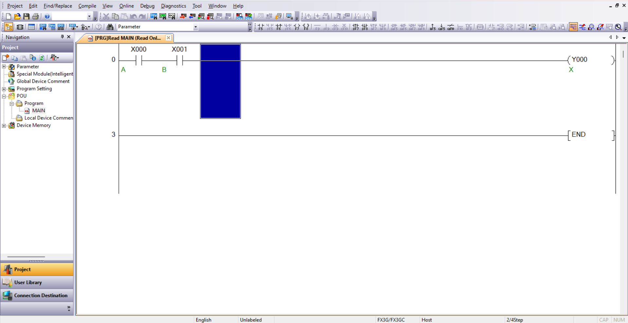
Figure 1 Circuit a
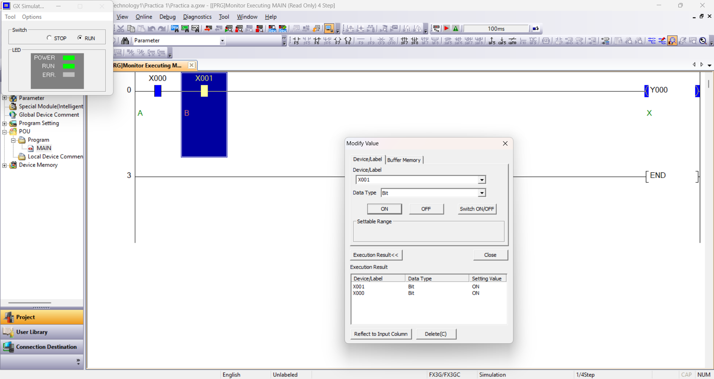
Figure 2 Test a

Circuit b:
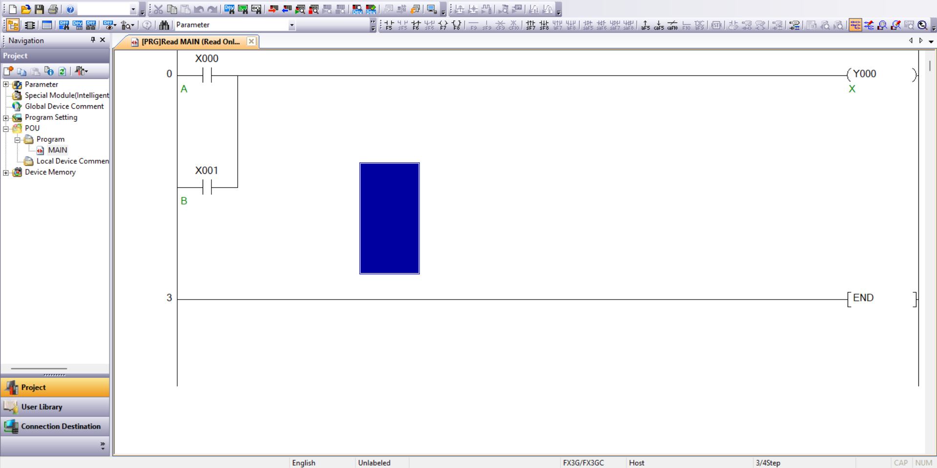
Figure 3 Circuit b
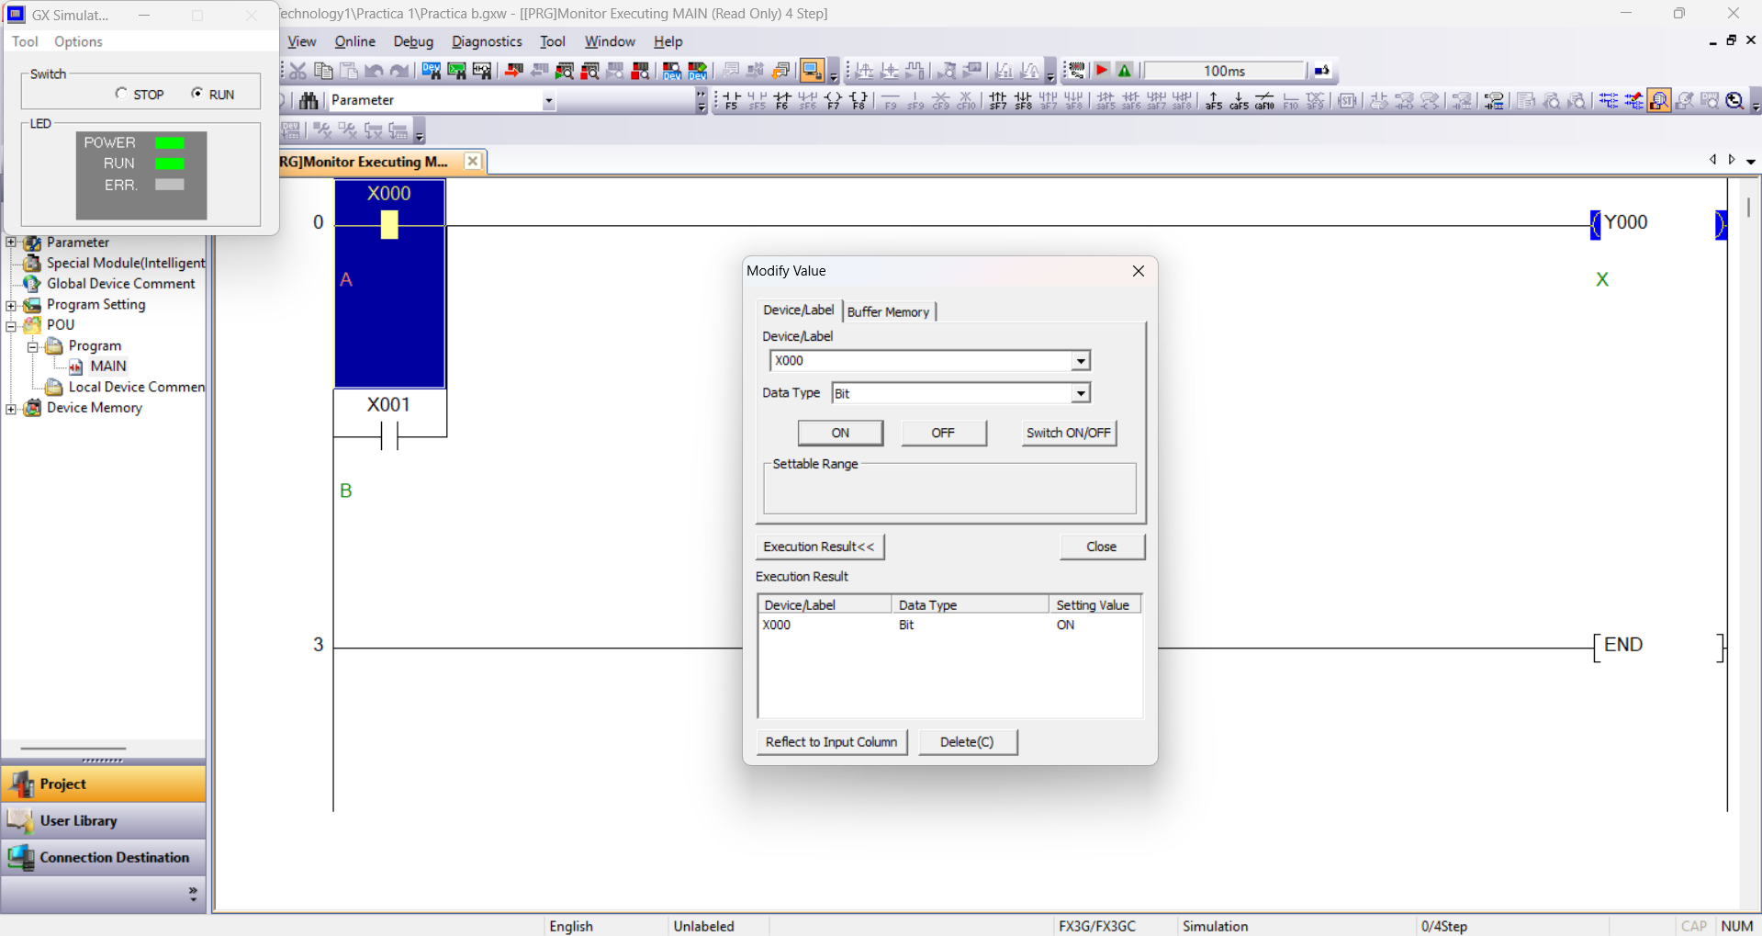
Figure 4 Test b

Circuit c:
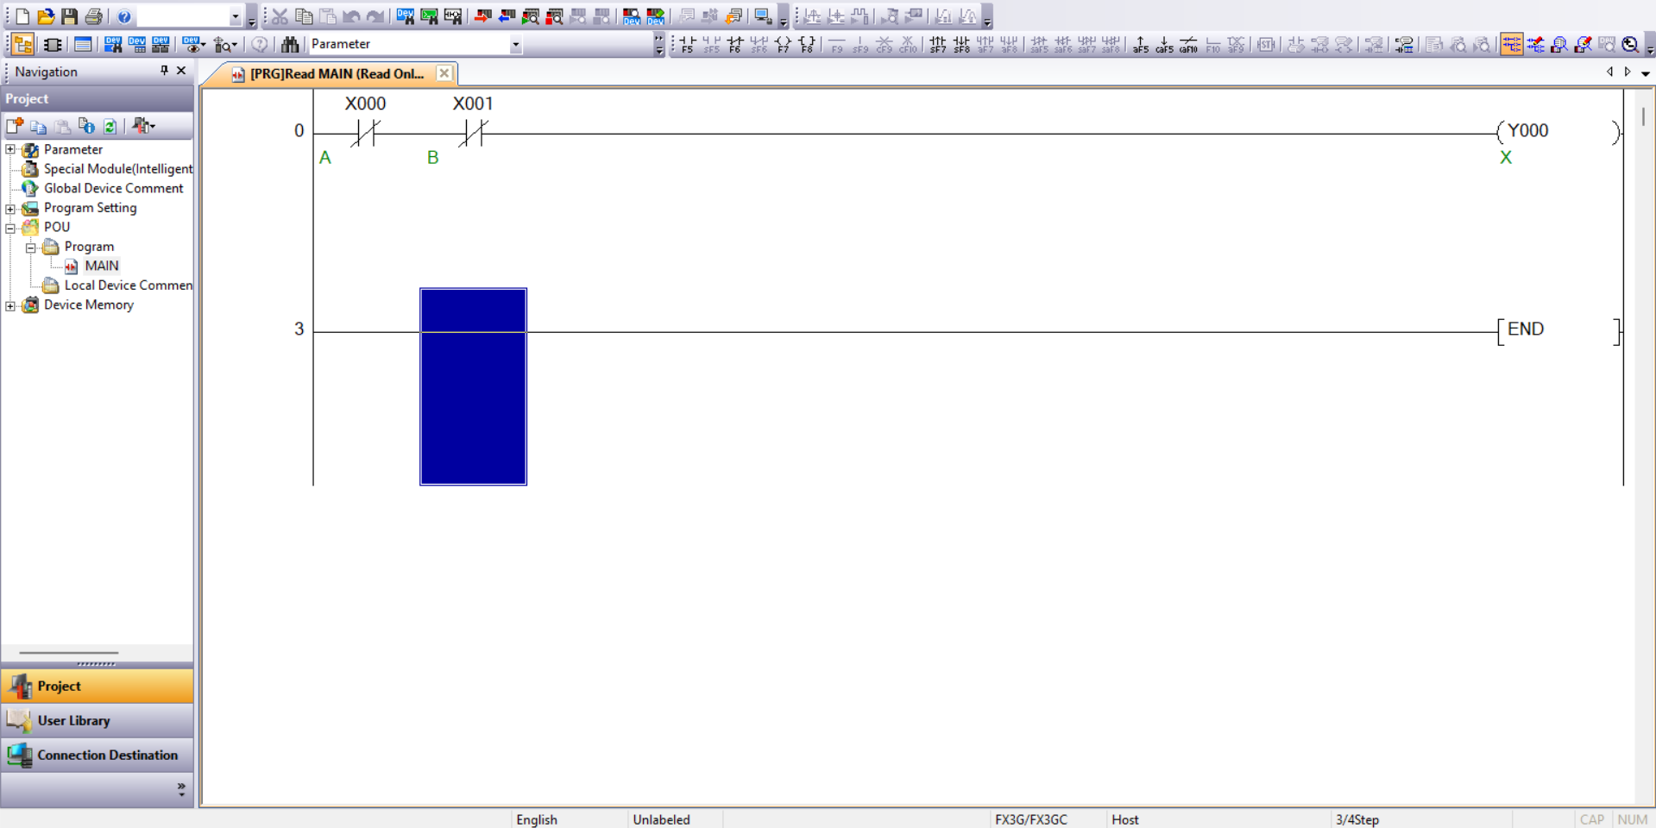
Figure 5 Circuit c
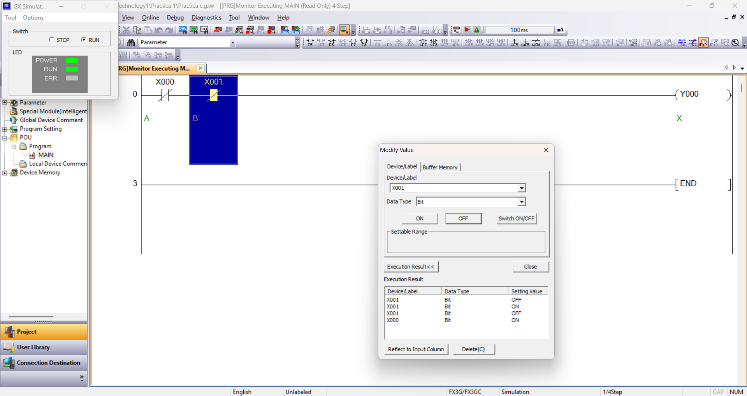
Figure 6 Test c

Circuit d:
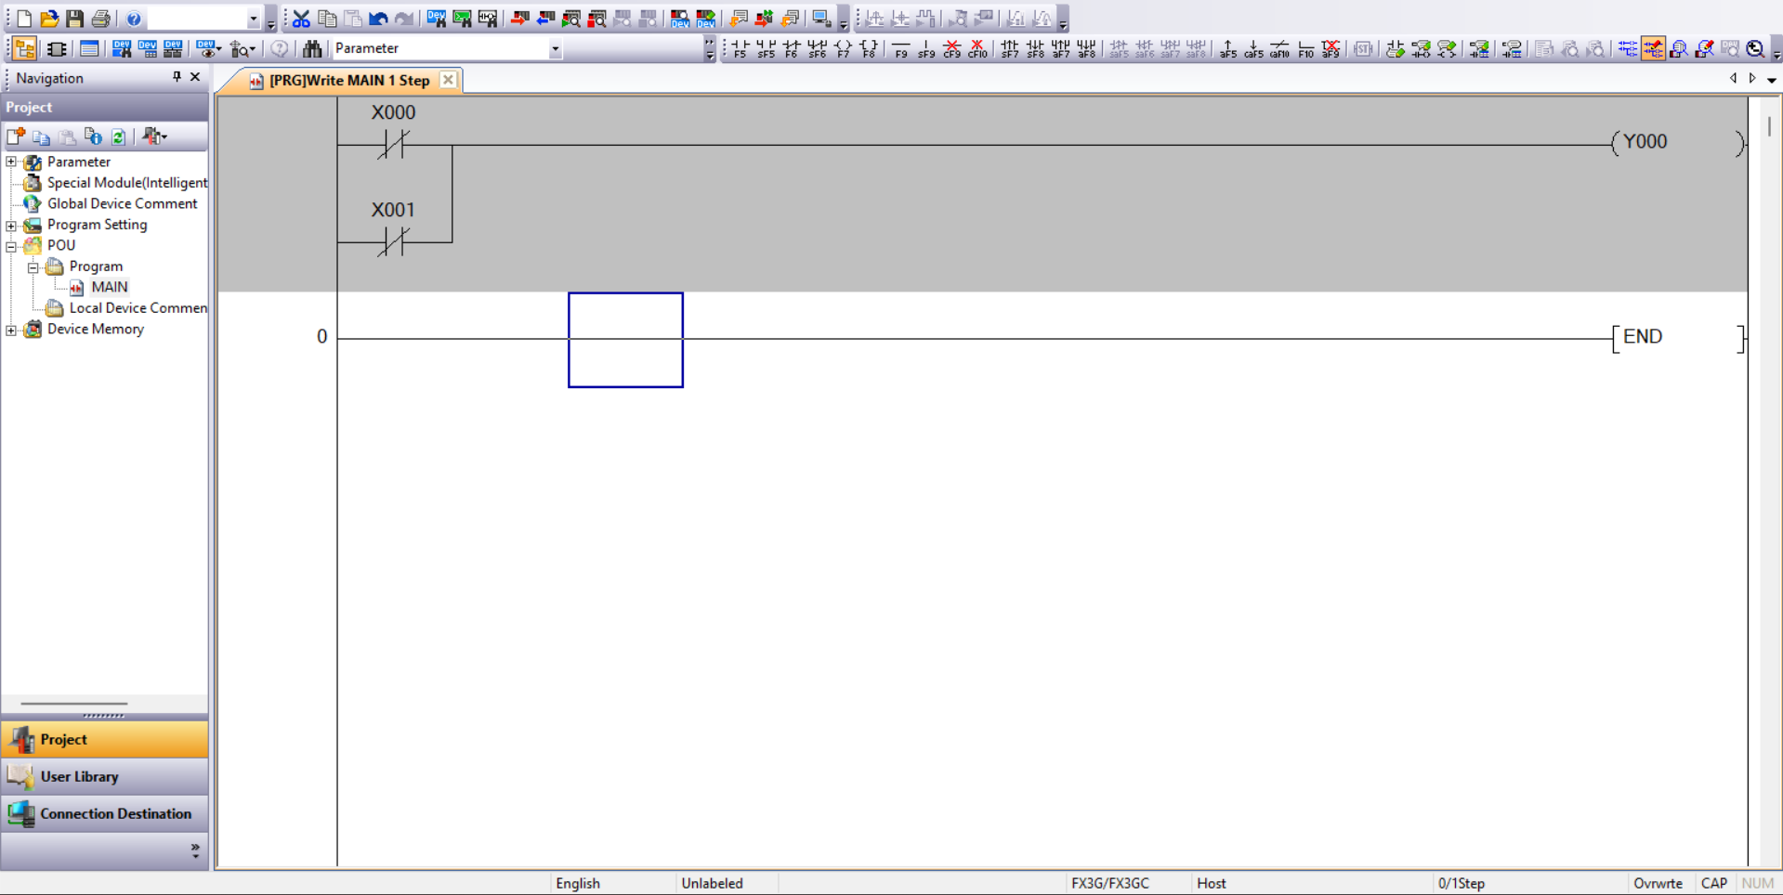
Figure 7 Circuit d
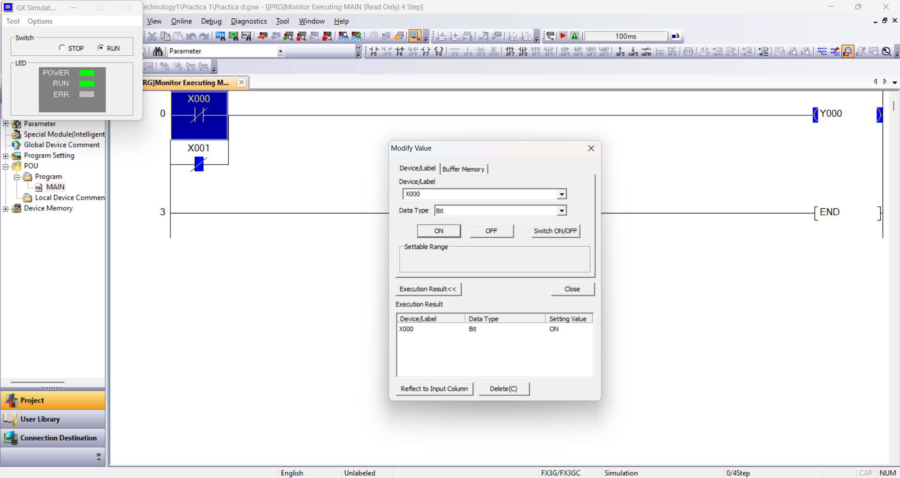
Figure 8 Test d

Circuit e:
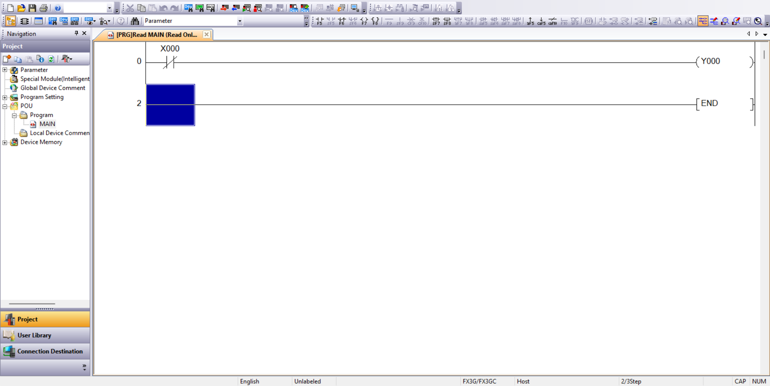
Figure 9 Circuit e
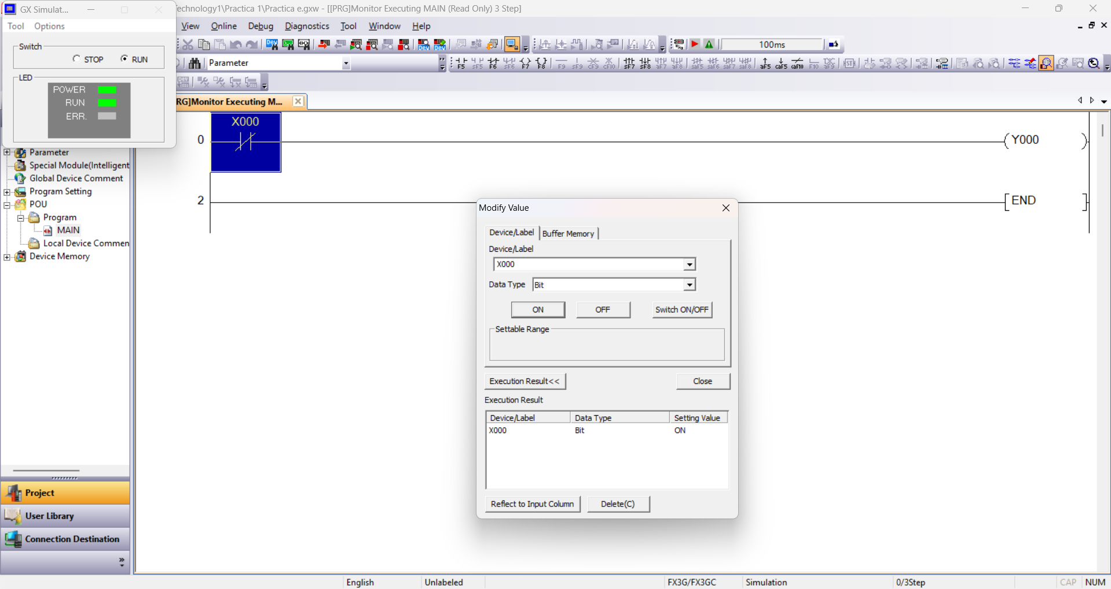
Figure 10 Test e

Circuit f:
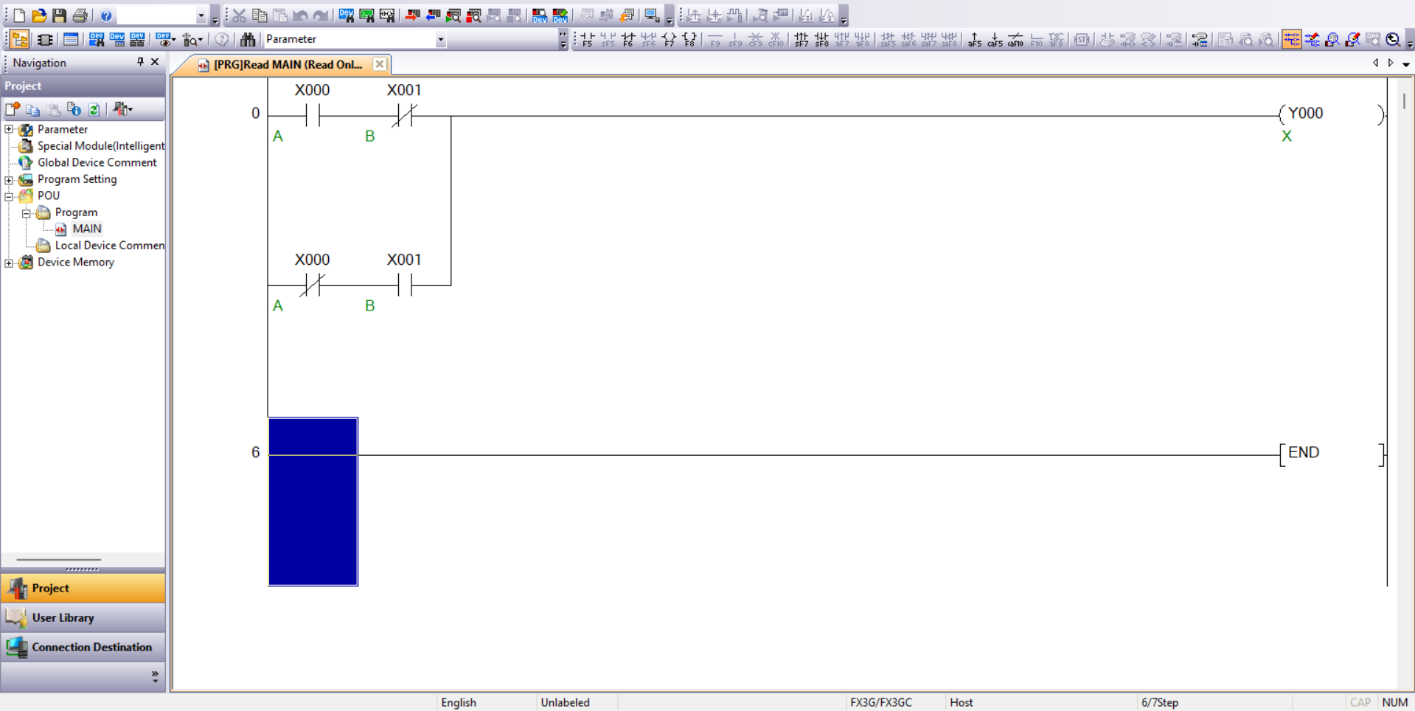
Figure 11 Circuit f
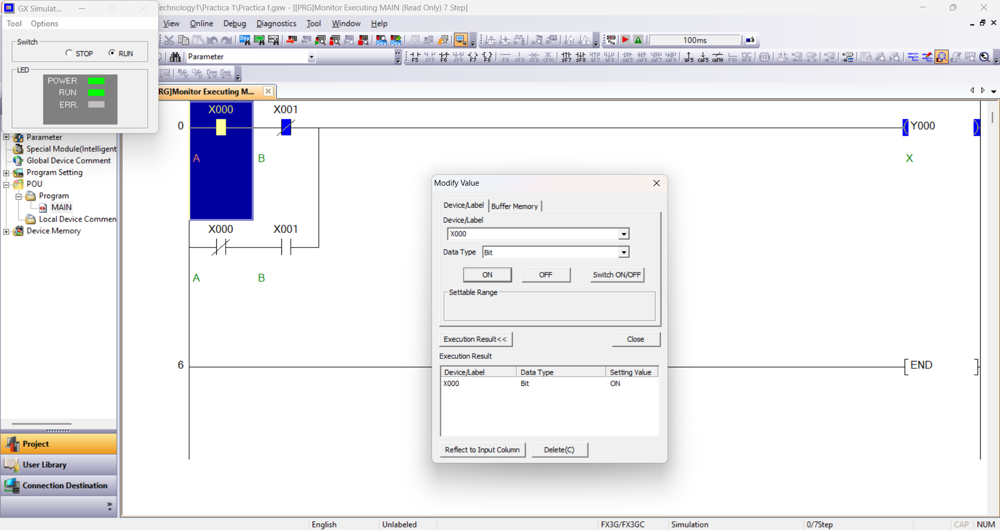
Figure 12 Test f

Using truth tables, establish the logic function for each circuit. Use Excel to generate a table for all variables.

See Excel file attached in the submission.

Section 3

Diagram
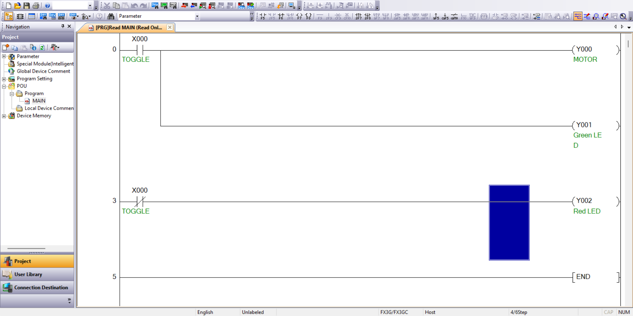
Figure 13 Diagram complete
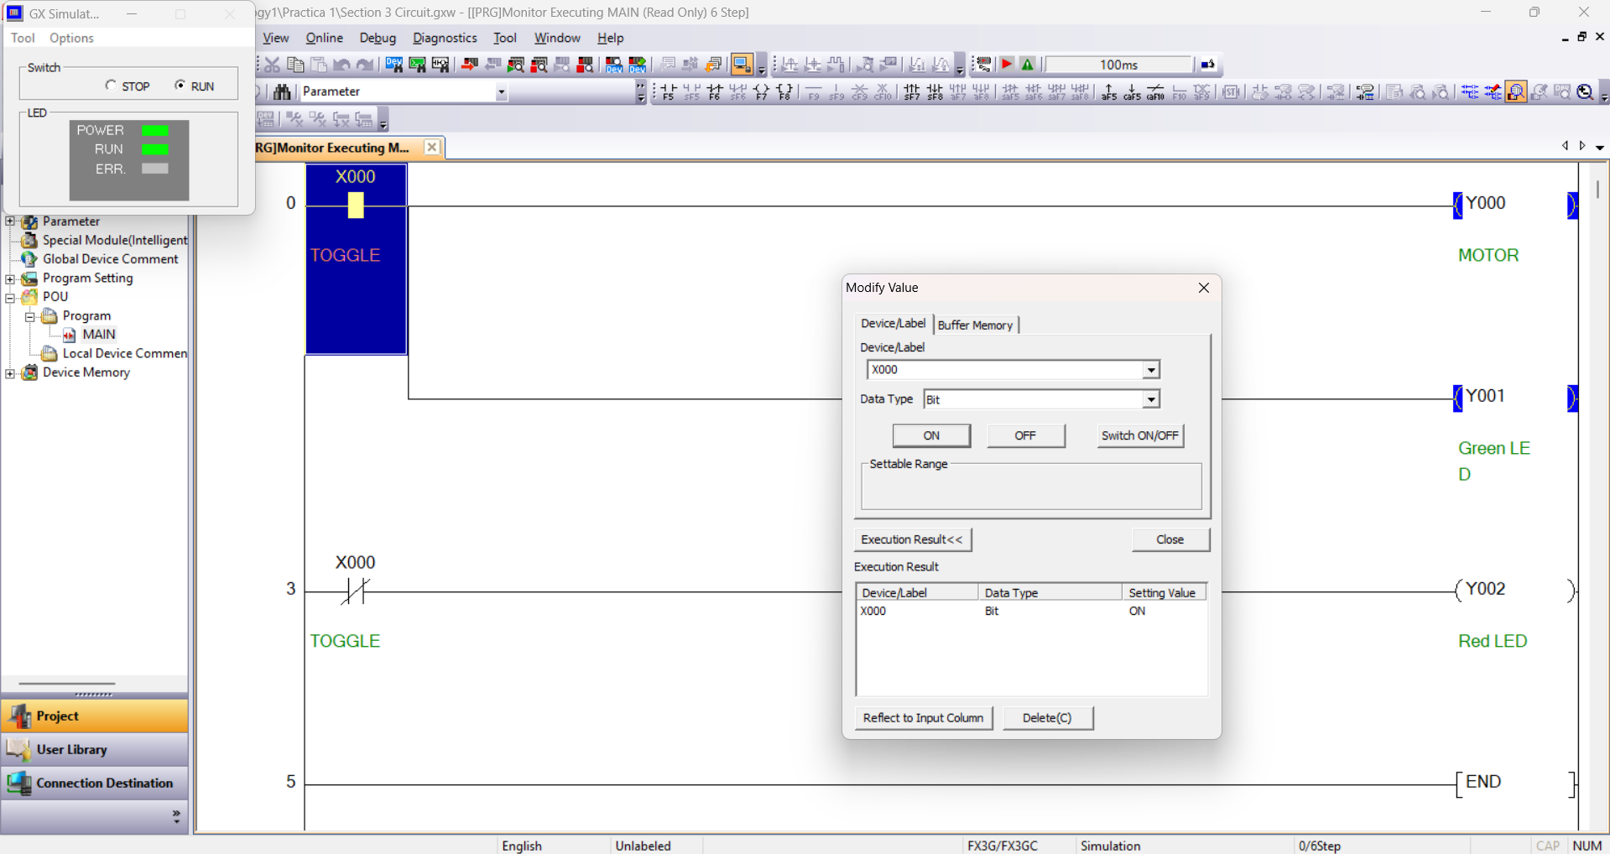
Figure 14 Diagram Test

PLC test unit

Wire the 3VDC motor using a control relay so that the motor operates with the ladder logic design. Hint: Two different voltages can be used to achieve the required result.

Three-phase (415V) supply Diagram
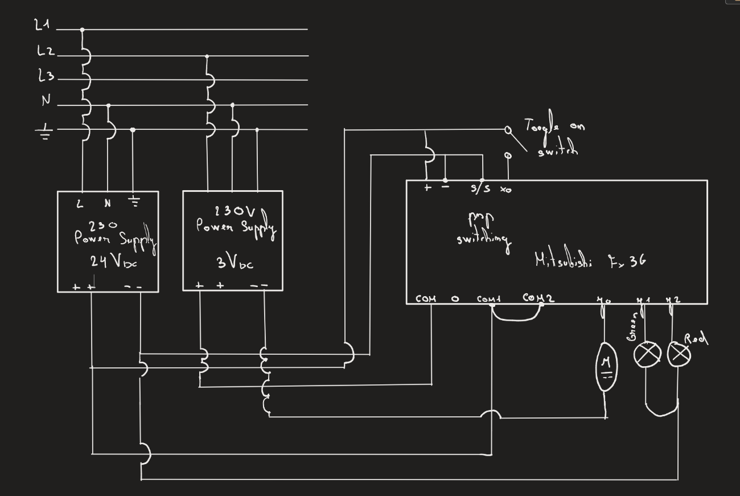
Figure 15 Supply power to the PLC and auxiliaries from a three-phase (415V) supply Diagram

Conclusion and Discussion of results

